Aaryan Pujara

# 102599490

Custom Project 6.2D

PORTFOLIO WEBSITE

I have decided to design a Personal Portfolio website for my Distinction project for this unit. The website that I have designed follows a mobile first design protocol, which means that the website will be able to adapt to any kind of display because it works on Bootstrap.

The website is actually a single page application that runs on VueCLI platform and is being hosted on a local server which can be accessed by local machine or any other devices(mobile) on the same network.

I have used multiple plug-ins for VueCLI including:

* Bootstrap
* Vue-Paginate
* Vuetify

In order to run this website, the user needs to have a few things as the initial setup. The instruction to do so are:

* Install VueCLI
* Build the project, change dependencies and npm run serve
* Open localhost:8080 on the machine or [http://192.168.20.112:**8080**/](http://192.168.20.112:8080/) on any other device on the same network.
* Once done, the website should be running on the machine.

The wireframes of the website demonstrate it is very user friendly and can be used on any device as it follows mobile first protocol.

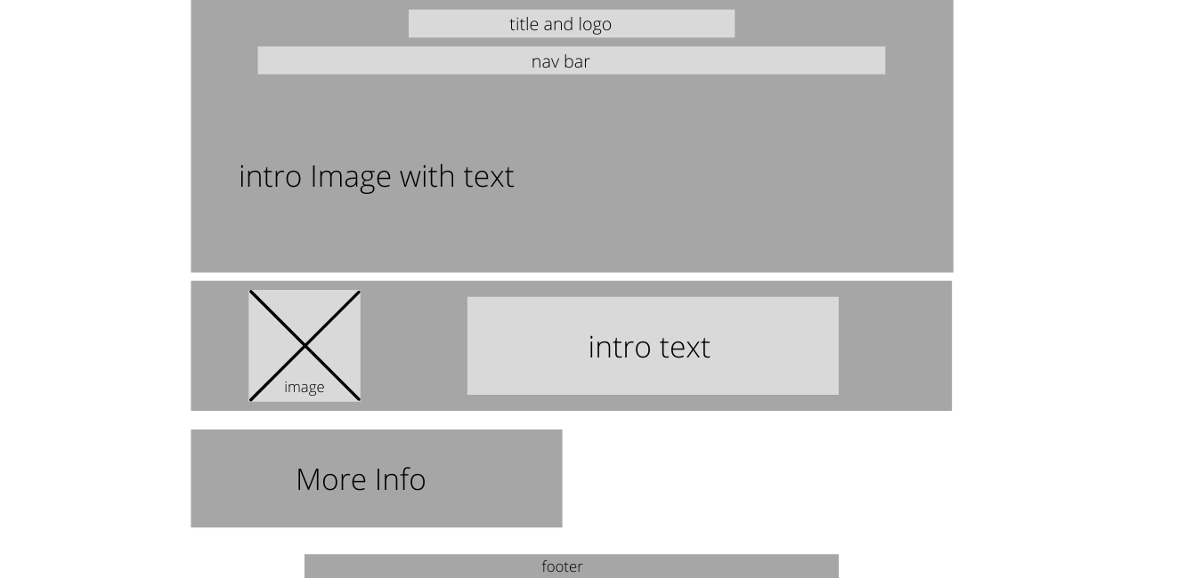

*Fig 1. Desktop Wireframe*

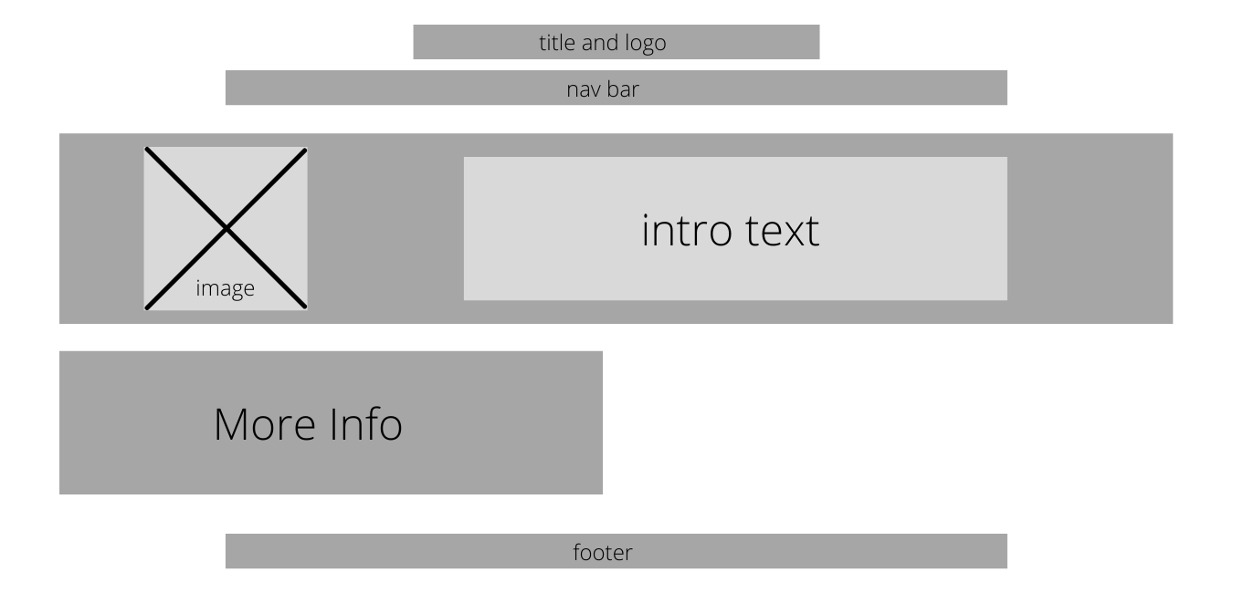

*Fig 2. Mobile Landscape Wireframe*

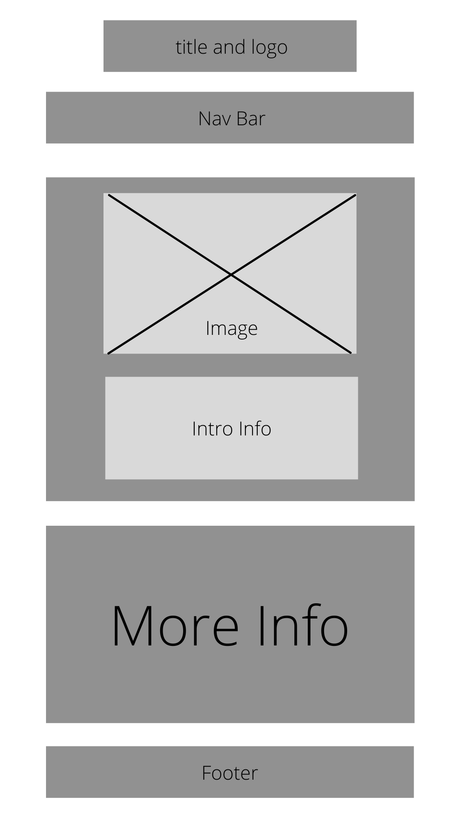

*Fig 3. Mobile Portrait Wireframe*

The website has been divided into a number of sections with their own Templates stored under src/views. The website has a App.vue file that makes sure that all the pages follow a same header, footer and CSS design language. The webpages are as follows:

* Home
* Experience
* Education
* Skills
* Contact

## Home

Home page consist of a picture a short description about myself and my interests and hobbies. The introduction image in Home page is adaptable and adjust itself with screen size. If the display is smaller than 1090PX then the image will automatically stop displaying as the measurements of the typewriter text doesn’t fit screens smaller than that.

## Experience

This page consists of all the professional and volunteering experience I have. This page was carefully designed to be used throughout any device with any kind of display. All the individual experiences have been divided by <div class = “row”> to make sure none of the part loses its scaling when viewed across multiple devices.

## Education

It consists of all the education that I have completed so far in my life. This page was carefully designed to be used throughout any device with any kind of display. All the individual educations have been divided by <div class = “col-sm”> to make sure none of the part loses its scaling when viewed across multiple devices.

## Skills

This part consists of a table that demonstrates, what kind of skills, what category of skills and the scale rating is that have been acquired by me. The skills that has been displayed in this particular web page are being populated by an external JSON file which then passes the data that the Script interprets and shows the data in a more user-friendly setting. This page also includes a vue-paginate feature which allows you to go through the page by a number slider and you can also filter through the skills using the filter option and find the category of skill you are looking for.

## Contact

This page includes personal contact information about me and a section to fill out the form just in case someone wants to get in contact with me. The form that I have integrated in this bitch goes to the Mercury server and is being stored there. The page also includes a section where you can leave feedback or comments and there is a functionality to delete this feedback or comments.

## Common

All the pages follow a similar design language using only three colors. All the pages have the same header and footer because that has been coded in the app file. All the pages share a similar CSS as well because the CSS that has been used to develop this website was boot strap and a bit of custom CSS which has been coded in the App.vue. The header of the website is interactive and changes colors when hovered over a specific element. The footer contains a hyperlink to the student email of the author which use a mailto element to open the mail box enabling user to email the author without any troubles.